**Modern College of Arts, Science and Commerce, Pune-05**

**Department of Statistics**

**M.Sc. II (Semester IV)**

**Date: Submission date:**

**Practical No. –**

**Title: Bayesian inference : Prior & Posterior Distribution.**

1. **Generate a random sample of size *n*=15 from *B*(10*,θ*) distribution with *θ*=0*.*45. Assuming that *β*(4*,*3) Is the priorfor *θ*.**
2. **Compute the posterior distribution of *θ*.**
3. **Plot the posterior density**
4. **Obtain 95% HPD credible interval for *θ***
5. **Generate a random sample of size *n*=20 from Poisson distribution with *θ*=1*.*52. Let the prior pdf of *θ* be given by**

***f*(*θ*)=4*θ*exp*{−*2*θ}; θ>0***

1. **Compute the posterior distribution of *θ*.**
2. **Plot the posterior density**
3. **Obtain 95% HPD credible interval for *θ***
4. **Generate a random sample of size *n*=30 from Normal distribution with mean *θ*=2*.*6 and variance 1.Let*N*(1*,*1) be the prior pdf of *θ*. Find the posterior distribution of *θ*.**
5. **Compute the posterior distribution of *θ*.**
6. **Plot the posterior density**
7. **Obtain 95% HPD credible interval for *θ***
8. **Generatearandomsampleofsize*n*=30from*U*(*−θ,θ*)with*θ*=2*.*2.Letthepriorpdfof*θ*begivenby**

**2**

***f*(*θ*)=*θ*3 *θ>*1**

1. **Compute the posterior distribution of *θ*.**
2. **Plot the posterior density**
3. **Obtain 95% HPD credible interval for *θ***

**Solution**

#Q1)Generatearandomsampleofsize*n*=15from*B*(10*,θ*)distributionwith*θ*=0*.*45.Assumingthat*β*(4*,*3)isthepriorfor*θ*,computetheposteriordistributionof*θ*.

> n=15

> theta = 0.45

> m = 10

> a = 4

> b = 3

> x = rbinom(n,m,theta)

> p = seq(0,1,length=100)

> p

[1] 0.00000000 0.01010101 0.02020202 0.03030303 0.04040404 0.05050505 0.06060606 0.07070707 0.08080808 0.09090909

[11] 0.10101010 0.11111111 0.12121212 0.13131313 0.14141414 0.15151515 0.16161616 0.17171717 0.18181818 0.19191919

[21] 0.20202020 0.21212121 0.22222222 0.23232323 0.24242424 0.25252525 0.26262626 0.27272727 0.28282828 0.29292929

[31] 0.30303030 0.31313131 0.32323232 0.33333333 0.34343434 0.35353535 0.36363636 0.37373737 0.38383838 0.39393939

[41] 0.40404040 0.41414141 0.42424242 0.43434343 0.44444444 0.45454545 0.46464646 0.47474747 0.48484848 0.49494949

[51] 0.50505051 0.51515152 0.52525253 0.53535354 0.54545455 0.55555556 0.56565657 0.57575758 0.58585859 0.59595960

[61] 0.60606061 0.61616162 0.62626263 0.63636364 0.64646465 0.65656566 0.66666667 0.67676768 0.68686869 0.69696970

[71] 0.70707071 0.71717172 0.72727273 0.73737374 0.74747475 0.75757576 0.76767677 0.77777778 0.78787879 0.79797980

[81] 0.80808081 0.81818182 0.82828283 0.83838384 0.84848485 0.85858586 0.86868687 0.87878788 0.88888889 0.89898990

[91] 0.90909091 0.91919192 0.92929293 0.93939394 0.94949495 0.95959596 0.96969697 0.97979798 0.98989899 1.00000000

> pr = dbeta(p,a,b)

> pr

[1] 0.000000e+00 6.059369e-05 4.749072e-04 1.569934e-03 3.644202e-03 6.968527e-03 1.178677e-02 1.831661e-02

[9] 2.675026e-02 3.725528e-02 4.997529e-02 6.503074e-02 8.251968e-02 1.025185e-01 1.250827e-01 1.502476e-01

[17] 1.780293e-01 2.084250e-01 2.414142e-01 2.769594e-01 3.150065e-01 3.554859e-01 3.983133e-01 4.433901e-01

[25] 4.906045e-01 5.398321e-01 5.909368e-01 6.437712e-01 6.981779e-01 7.539896e-01 8.110306e-01 8.691169e-01

[33] 9.280574e-01 9.876543e-01 1.047704e+00 1.107999e+00 1.168326e+00 1.228468e+00 1.288207e+00 1.347323e+00

[41] 1.405592e+00 1.462793e+00 1.518703e+00 1.573101e+00 1.625768e+00 1.676488e+00 1.725045e+00 1.771232e+00

[49] 1.814844e+00 1.855682e+00 1.893553e+00 1.928272e+00 1.959661e+00 1.987552e+00 2.011785e+00 2.032211e+00

[57] 2.048690e+00 2.061097e+00 2.069317e+00 2.073248e+00 2.072804e+00 2.067912e+00 2.058514e+00 2.044570e+00

[65] 2.026055e+00 2.002964e+00 1.975309e+00 1.943120e+00 1.906450e+00 1.865370e+00 1.819975e+00 1.770380e+00

[73] 1.716723e+00 1.659169e+00 1.597903e+00 1.533139e+00 1.465115e+00 1.394096e+00 1.320376e+00 1.244275e+00

[81] 1.166145e+00 1.086364e+00 1.005344e+00 9.235268e-01 8.413867e-01 7.594307e-01 6.781993e-01 5.982677e-01

[89] 5.202459e-01 4.447800e-01 3.725528e-01 3.042842e-01 2.407326e-01 1.826950e-01 1.310083e-01 8.654980e-02

[97] 5.023790e-02 2.303300e-02 5.938182e-03 0.000000e+00

> sum(x)+a

[1] 76

> m*n-sum(x)+b

[1] 81

> #Posterior distribution of theta is beta distribution with parameters m=76 and n=82

> po = dbeta(p,sum(x)+a,m*n-sum(x)+b)

> plot(p,pr,ylim = c(0,10),main = "Prior and Posterior Density Plot")

> lines(p,po,col = "red")

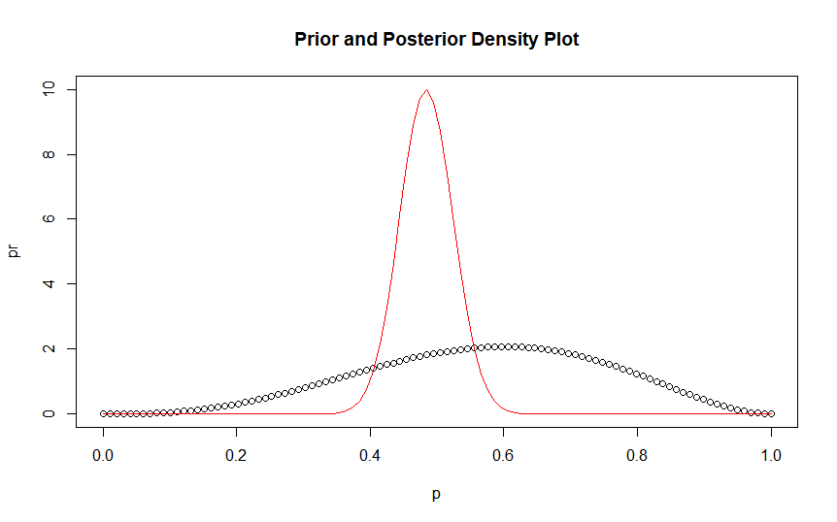

> #The above graph shows the prior and posterior probabilities for different values of theta. Red indicates the posterior distribution whereas black indicates the prior distribution for different values of theta. It can be seen that the probability for theta = 0 .45 is maximum.

> #1.Generatea random sample of size n=20 from Poisson distribution with θ=1.52. Let the prior pdf of θ be given by f(θ)=4θexp{−2θ}

> #q2

> n=20

> theta = 1.52

> lambda = 2

> alpha = 2

> x = rpois(n,theta)

> p = seq(0,5,length=100)

> p

[1] 0.00000000 0.05050505 0.10101010 0.15151515 0.20202020 0.25252525 0.30303030 0.35353535 0.40404040 0.45454545

[11] 0.50505051 0.55555556 0.60606061 0.65656566 0.70707071 0.75757576 0.80808081 0.85858586 0.90909091 0.95959596

[21] 1.01010101 1.06060606 1.11111111 1.16161616 1.21212121 1.26262626 1.31313131 1.36363636 1.41414141 1.46464646

[31] 1.51515152 1.56565657 1.61616162 1.66666667 1.71717172 1.76767677 1.81818182 1.86868687 1.91919192 1.96969697

[41] 2.02020202 2.07070707 2.12121212 2.17171717 2.22222222 2.27272727 2.32323232 2.37373737 2.42424242 2.47474747

[51] 2.52525253 2.57575758 2.62626263 2.67676768 2.72727273 2.77777778 2.82828283 2.87878788 2.92929293 2.97979798

[61] 3.03030303 3.08080808 3.13131313 3.18181818 3.23232323 3.28282828 3.33333333 3.38383838 3.43434343 3.48484848

[71] 3.53535354 3.58585859 3.63636364 3.68686869 3.73737374 3.78787879 3.83838384 3.88888889 3.93939394 3.98989899

[81] 4.04040404 4.09090909 4.14141414 4.19191919 4.24242424 4.29292929 4.34343434 4.39393939 4.44444444 4.49494949

[91] 4.54545455 4.59595960 4.64646465 4.69696970 4.74747475 4.79797980 4.84848485 4.89898990 4.94949495 5.00000000

> pr = dgamma(p,lambda,alpha) #dgamma(p,shape,scale)

> sum(x)+2

[1] 31

> n+2

[1] 22

> po = dgamma(p,sum(x)+2,n+2) #dgamma(p,shape,scale)

> plot(p,pr,ylim = c(0,2),main = "Prior and Posterior Density Plot")

> lines(p,po,col = "red")

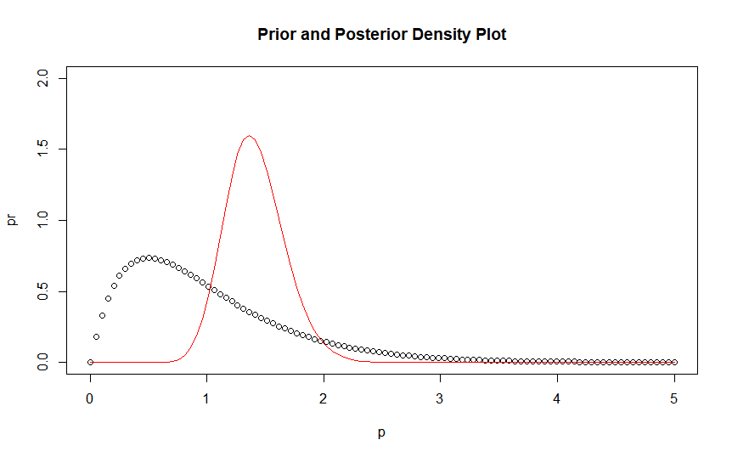

> #The above graph shows the prior and posterior probabilities for different values of theta. Red indicates the posterior distribution whereas black indicates the prior distribution for different values of theta. It can be seen that the probability for theta = 1.6 approxis maximum.

> #2.Generatearandomsampleofsizen=30fromNormaldistributionwithmeanθ=2.6andvariance1.LetN(1,1)bethepriorpdfofθ.Findtheposteriordistributionofθ.

> #q3

> n=30

> theta = 2.6

> sd = 1

> x = rnorm(n,theta,sd)

> p = seq(-5,5,length=100)

> p

[1] -5.00000000 -4.89898990 -4.79797980 -4.69696970 -4.59595960 -4.49494949 -4.39393939 -4.29292929 -4.19191919

[10] -4.09090909 -3.98989899 -3.88888889 -3.78787879 -3.68686869 -3.58585859 -3.48484848 -3.38383838 -3.28282828

[19] -3.18181818 -3.08080808 -2.97979798 -2.87878788 -2.77777778 -2.67676768 -2.57575758 -2.47474747 -2.37373737

[28] -2.27272727 -2.17171717 -2.07070707 -1.96969697 -1.86868687 -1.76767677 -1.66666667 -1.56565657 -1.46464646

[37] -1.36363636 -1.26262626 -1.16161616 -1.06060606 -0.95959596 -0.85858586 -0.75757576 -0.65656566 -0.55555556

[46] -0.45454545 -0.35353535 -0.25252525 -0.15151515 -0.05050505 0.05050505 0.15151515 0.25252525 0.35353535

[55] 0.45454545 0.55555556 0.65656566 0.75757576 0.85858586 0.95959596 1.06060606 1.16161616 1.26262626

[64] 1.36363636 1.46464646 1.56565657 1.66666667 1.76767677 1.86868687 1.96969697 2.07070707 2.17171717

[73] 2.27272727 2.37373737 2.47474747 2.57575758 2.67676768 2.77777778 2.87878788 2.97979798 3.08080808

[82] 3.18181818 3.28282828 3.38383838 3.48484848 3.58585859 3.68686869 3.78787879 3.88888889 3.98989899

[91] 4.09090909 4.19191919 4.29292929 4.39393939 4.49494949 4.59595960 4.69696970 4.79797980 4.89898990

[100] 5.00000000

> pr = dnorm(p,1,1) #dgamma(p,shape,scale)

> (sum(x)+1)/(n+1)

[1] 2.594863

> 1/(n+1)

[1] 0.03225806

> #Posterior distribution of theta is normal distribution with parameters mu = 2.594863 and sigma = 0.03225806

> po = dnorm(p,(sum(x)+1)/(n+1),1/(n+1))

> plot(p,pr,xlim = c(-5,6),ylim = c(0,5),main = "Prior and Posterior Density Plot")

> lines(p,po,col = "red")

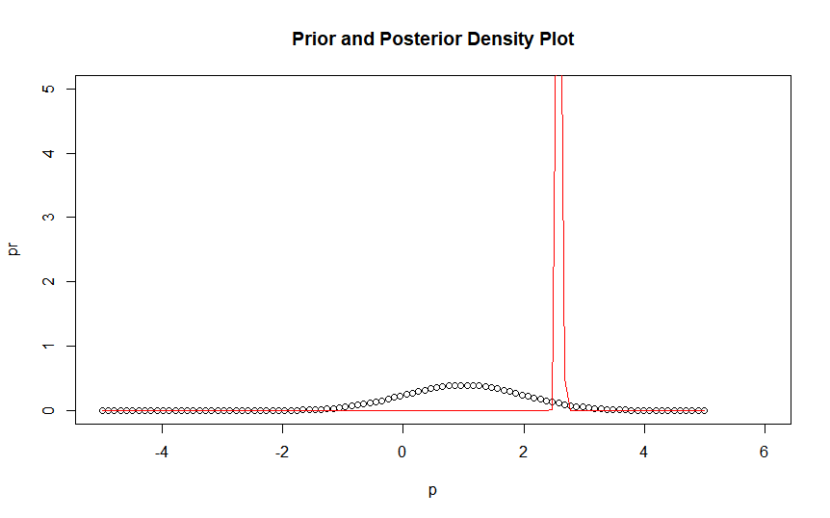

> #The above graph shows the prior and posterior probabilities for different values of theta. Red indicates the posterior distribution whereas black indicates the prior distribution for different values of theta. It can be seen that the probability for theta = 2.4 approx is maximum.

> #3.Generatearandomsampleofsizen=30fromU(−θ,θ)withθ=2.2.Letthepriorpdfofθbegivenby

> 2

[1] 2

> #q4

> n=30

> theta = 2.2

> x = runif(n,-theta,theta)

> x1 = min(x)

> xn = max(x)

> t = max(xn,-x1,1)

> p = seq(t,5,length=100)

> p

[1] 2.177879 2.206386 2.234892 2.263398 2.291904 2.320411 2.348917 2.377423 2.405930 2.434436 2.462942 2.491448

[13] 2.519955 2.548461 2.576967 2.605473 2.633980 2.662486 2.690992 2.719498 2.748005 2.776511 2.805017 2.833524

[25] 2.862030 2.890536 2.919042 2.947549 2.976055 3.004561 3.033067 3.061574 3.090080 3.118586 3.147093 3.175599

[37] 3.204105 3.232611 3.261118 3.289624 3.318130 3.346636 3.375143 3.403649 3.432155 3.460661 3.489168 3.517674

[49] 3.546180 3.574687 3.603193 3.631699 3.660205 3.688712 3.717218 3.745724 3.774230 3.802737 3.831243 3.859749

[61] 3.888256 3.916762 3.945268 3.973774 4.002281 4.030787 4.059293 4.087799 4.116306 4.144812 4.173318 4.201824

[73] 4.230331 4.258837 4.287343 4.315850 4.344356 4.372862 4.401368 4.429875 4.458381 4.486887 4.515393 4.543900

[85] 4.572406 4.600912 4.629419 4.657925 4.686431 4.714937 4.743444 4.771950 4.800456 4.828962 4.857469 4.885975

[97] 4.914481 4.942987 4.971494 5.000000

> pr = 2/(p^3)

> #The posterior distribution of theta is given as follows : where t = max { }

> ((n+2)*t^(n+2))/(p^(n+3))

[1] 1.469319e+01 9.566329e+00 6.262778e+00 4.122119e+00 2.727392e+00 1.813810e+00 1.212270e+00 8.141746e-01

[9] 5.494099e-01 3.724668e-01 2.536552e-01 1.735082e-01 1.191990e-01 8.223549e-02 5.696908e-02 3.962534e-02

[17] 2.767084e-02 1.939772e-02 1.364966e-02 9.640536e-03 6.833693e-03 4.861295e-03 3.470239e-03 2.485690e-03

[25] 1.786426e-03 1.288087e-03 9.317494e-04 6.761140e-04 4.921316e-04 3.593003e-04 2.631019e-04 1.932220e-04

[33] 1.423087e-04 1.051057e-04 7.784279e-05 5.780782e-05 4.304370e-05 3.213417e-05 2.405133e-05 1.804705e-05

[41] 1.357530e-05 1.023648e-05 7.737342e-06 5.862127e-06 4.451680e-06 3.388296e-06 2.584707e-06 1.976049e-06

[49] 1.513999e-06 1.162464e-06 8.944265e-07 6.896154e-07 5.327854e-07 4.124459e-07 3.199172e-07 2.486286e-07

[57] 1.935952e-07 1.510274e-07 1.180381e-07 9.242347e-08 7.249766e-08 5.696866e-08 4.484430e-08 3.536118e-08

[65] 2.793082e-08 2.209875e-08 1.751333e-08 1.390197e-08 1.105302e-08 8.801828e-09 7.020092e-09 5.607656e-09

[73] 4.486210e-09 3.594418e-09 2.884163e-09 2.317632e-09 1.865067e-09 1.503009e-09 1.212935e-09 9.802005e-10

[81] 7.932055e-10 6.427505e-10 5.215279e-10 4.237249e-10 3.447104e-10 2.807902e-10 2.290127e-10 1.870169e-10

[89] 1.529110e-10 1.251777e-10 1.025980e-10 8.419155e-11 6.916870e-11 5.689264e-11 4.684918e-11 3.862260e-11

[97] 3.187637e-11 2.633774e-11 2.178536e-11 1.803940e-11

> po = ((n+2)*t^(n+2))/(p^(n+3))

> plot(p,pr,ylim = c(0,20),main = "Prior and Posterior Density Plot")

> lines(p,po,col = "red")

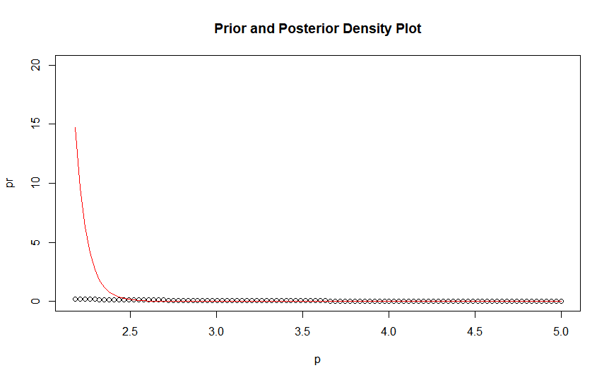

> #The above graph shows the prior and posterior probabilities for different values of theta. Red indicates the posterior distribution whereas black indicates the prior distribution for different values of theta. It can be seen that the probability for theta = 2.2 approx is maximum.